PIZZA SALES SQL QUERIES
A. KPI’s
1. Total Revenue:
SELECT SUM(total_price) AS Total_Revenue FROM pizza_sales;
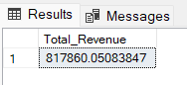
2. Average Order Value
SELECT (SUM(total_price) / COUNT(DISTINCT order_id)) AS Avg_order_Value FROM pizza_sales
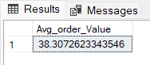
3. Total Pizzas Sold
SELECT SUM(quantity) AS Total_pizza_sold FROM pizza_sales
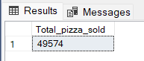
4. Total Orders
SELECT COUNT(DISTINCT order_id) AS Total_Orders FROM pizza_sales
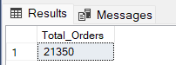
5. Average Pizzas Per Order
SELECT CAST(CAST(SUM(quantity) AS DECIMAL(10,2)) /
CAST(COUNT(DISTINCT order_id) AS DECIMAL(10,2)) AS DECIMAL(10,2))
AS Avg_Pizzas_per_order
FROM pizza_sales
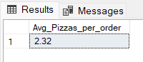
B. Daily Trend for Total Orders
SELECT DATENAME(DW, order_date) AS order_day, COUNT(DISTINCT order_id) AS total_orders
FROM pizza_sales
GROUP BY DATENAME(DW, order_date)
Output:
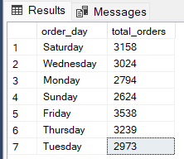
C. Hourly Trend for Orders
SELECT DATEPART(HOUR, order_time) as order_hours, COUNT(DISTINCT order_id) as total_orders
from pizza_sales
group by DATEPART(HOUR, order_time)
order by DATEPART(HOUR, order_time)
Output
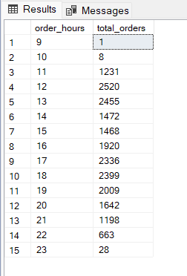
D. % of Sales by Pizza Category
SELECT pizza_category, CAST(SUM(total_price) AS DECIMAL(10,2)) as total_revenue,
CAST(SUM(total_price) * 100 / (SELECT SUM(total_price) from pizza_sales) AS DECIMAL(10,2)) AS PCT
FROM pizza_sales
GROUP BY pizza_category
Output
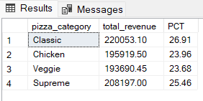
E. % of Sales by Pizza Size
SELECT pizza_size, CAST(SUM(total_price) AS DECIMAL(10,2)) as total_revenue,
CAST(SUM(total_price) * 100 / (SELECT SUM(total_price) from pizza_sales) AS DECIMAL(10,2)) AS PCT
FROM pizza_sales
GROUP BY pizza_size
ORDER BY pizza_size
Output
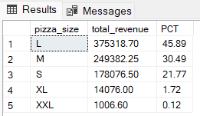

F. Total Pizzas Sold by Pizza Category
SELECT pizza_category, SUM(quantity) as Total_Quantity_Sold
FROM pizza_sales
WHERE MONTH(order_date) = 2
GROUP BY pizza_category
ORDER BY Total_Quantity_Sold DESC
Output
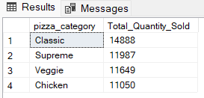
G. Top 5 Best Sellers by Total Pizzas Sold
SELECT Top 5 pizza_name, SUM(quantity) AS Total_Pizza_Sold
FROM pizza_sales
GROUP BY pizza_name
ORDER BY Total_Pizza_Sold DESC
Output
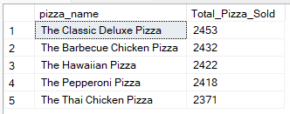

H. Bottom 5 Best Sellers by Total Pizzas Sold
SELECT TOP 5 pizza_name, SUM(quantity) AS Total_Pizza_Sold
FROM pizza_sales
GROUP BY pizza_name
ORDER BY Total_Pizza_Sold ASC
Output
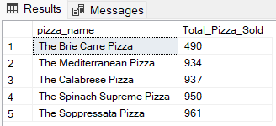

NOTE
If we want to apply the Month, Quarter, Week filters to the above queries we can use WHERE clause. Follow some of below examples
SELECT DATENAME(DW, order_date) AS order_day, COUNT(DISTINCT order_id) AS total_orders
FROM pizza_sales
WHERE MONTH(order_date) = 1
GROUP BY DATENAME(DW, order_date)

*Here MONTH(order_date) = 1 indicates that the output is for the month of January. MONTH(order_date) = 4 indicates output for Month of April.

SELECT DATENAME(DW, order_date) AS order_day, COUNT(DISTINCT order_id) AS total_orders
FROM pizza_sales
WHERE DATEPART(QUARTER, order_date) = 1
GROUP BY DATENAME(DW, order_date)

*Here DATEPART(QUARTER, order_date) = 1 indicates that the output is for the Quarter 1. MONTH(order_date) = 3 indicates output for Quarter 3.

